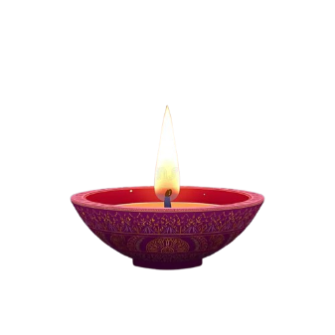


Wishing you a Diwali that brings happiness, prosperity and joy to you and your family
HAPPY DIWALI

